- BH EVENT

FORM TO BE FILLED IN A WEEK BEFORE THE EVENT

Name of the event | Days
SPORTA MONT VENTOUX | 2

Address expo
SPORTA VILLAGE
Parking Communal, Route de Carpentras 182,
84410 Bédoin

Town/City | Postcode | Country
Bédoin (Event) | 84410 | FRANCE
Hotel and evening catering |  | 20-23.06
hôtel Domaine des Tilleuls  Route du Grozeau,  84340 Malaucène (hotel) |  | Check in 14.00  Check out 12.00
Rooms |  | 3
Sander Zwijnenberg |  | TH to SU
Dimitri Fauville |  | TH to SU
Nicolas Lemajeur |  | TH to SU

Team Arrival for setup in Bedouin | Time
Thursday 20.06 – Nico – Dimi – Sander | 10.00
Leaving Expected Time
Sunday 25.06 | 9:00

BH Staff on site
BH staff | Phone | 1st day in the setup | Final check out
Nicolas Lemajeur | 0032 472428402 | 20.06 | 23.06
Dimitri Fauville |  | 20.06 | 23.06
Sander Zwijnenberg |  | 20.06 | 23.06

TIMELINE
Final loading Van | Monday AM | 18.06 | Who | Nico
Van to Ventoux | Wednesday | 19.06 @12.00 | Who | Nico+Dimi
Sander naar Ventoux | Wednesday | 19.09 | Who | Sander
Stop under LYON (TBD) | Wednesday | 19.09 | Who
Cleaning bikes in Bedouin | Thursday | 20.06 at 10 AM | Who | Nico+Sander+Dimi
Setup Boot | Thursday | 20.06 | Who | Nico+Sander+Dimi
Welcome guests and PR | Fri+Sat | 21.06 | Who | Nico+Sander+Dimi
Retour Material Kapellen | Mon | 24.06 | Who | Nico

DRESS CODE DURING THE EVENT
Thursday: Partner event Hotel: casual chic
Friday: grey polo, dark short of trousers, dark shoes
Saturday: Burg. Polo, dark short of trousers, dark shoes

BIKES EXPO
DX904 SRS MD | Lynx Race 9.0 LT
EC153-BBB-MD | Core race 1.5
ES494 NWN MD | Atom-E SUV Pro
ES824-RRR-SM | Atom-e Lynx Pro
LD603 SSS LA | Aerolight 6.0
LR705-RRR-XL | Ultralight 7.0 MY25
LG403 CNN MD | GRAVELX EVO 4.0 GRX DI2 11V
EC184 RCR LA | iAerolight 1.8
LA505 CCO MD | RS1 5.0 MY25

FLOOR PLAN (ATTACHED) STAND
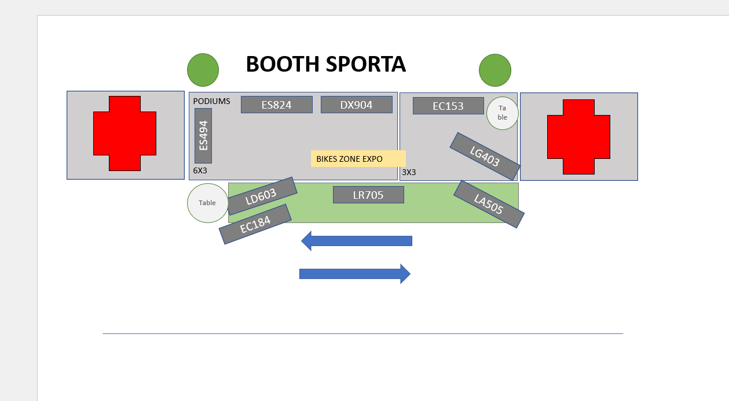

ANIMATION
- Bike presentation during registration day
- Raffle goodies on the booth (drive social media)
- BH presentations during the evening
- Winner of the gravel 2.0 bike during the party

RULES OF USE
The stand represents our image and everyone is responsible for keeping it clean, with the display and test bikes tidily arranged. No personal belongings should be visible (rucksacks, coats, sweaters, etc.).
Every day of the Trade Show/Event, you must arrive 1 hour beforehand to prepare and clean the whole stand before it opens.
At the end of every day of the Trade Show/Event, you must close the stand and leave it tidy for the following day.
Customer service is one of the most important points. You must have a suitable attitude and be available to customers at all time.
The dress code should portray a unified corporate image.

Duties of the manager and BH staff present
The event manager will coordinate and carry out the following together with the BH employees who are present:
- Assembly prior to the event and dismantling after the event has finished.
- Maintenance and cleaning.

Assembly prior to the event and dismantling after the event has finished
- Assembly defined by BH Bikes Marketing.
  - Installation of tents.
  - Exhibition of display and test bikes.
  - Expo bikes, coordinate.
  - (Coordinator) They will assign the staff duties during the event.
  - Customer service a priority; we are representing BH's image.
  - Continuous cleaning and maintenance of the lorry.
- At least 2people from BH Bikes
- Do not answer the telephones during assembly and dismantling.

Maintenance and cleaning
Every day, before and after each event opens (1 hour beforehand) / after it closes (1 hour afterwards).
- Vacuum.
- Clean podiums, cleaning kit.
- Dispose of rubbish.
- The BH employees' clothing, rucksacks, coats, etc. should not be visible.
- The lorry requires continuous, thorough cleaning (bottles, bikes, coffees, rubbish, etc.).
Maintenance during the event.
  - Placement and cleaning of the bikes and podiums, meeting tables.
Maintenance during the event.
Before the event opens (1 hour beforehand) / after it closes (1 hour afterwards).
  - Install speakers with music from Spotify defined by BH.
  - Turn on the lorry's TV and play action videos.
IMPORTANT Everyone is responsible for picking up their visitors' rubbish and restocking the fridge and snacks.

MECHANICAL AREA
Outsourced by the Sporta organisation

DEMO MANAGEMENT
- N/A

BIKE CHECKS
- The day after the event ends.
- Protocol detailing parts of each bike to be checked for the event.
  - Attached.
  - Electrical spare parts and electrical cases available for e-bikes.
- Report any problems that cannot be fixed during servicing.
  - Attached.
  - Send email with the report to:
    - Alberto alberto.municio@bhbikes.com
    - Álvaro alvaro.olasolo@bhbikes.com
    - Maria maria@bhbikes.com
- Carry out maintenance, check and clean all bikes after the end of the event.
  - Clean bikes with the Karcher cleaner on the lorry or in the cleaning area.
  - Bikes should be clean and must have been checked before being placed on the lorry.
  - Electrical cases tidily arranged.

Event manager signature
NICOLAS LEMAJEUR

